Software Requirements Specification

for

Trivia Maze
Version 1.0 approved
Prepared by Jeff Clark
Cody Demianew
JD Hall
Beto Lopez
May 15, 2014
Table of Contents
Table of Contents ii
Revision History ii
1. Introduction 1
1.1 Purpose 1
1.2 Project Scope and Product Features 1
2. Overall Description 1
2.1 Product Perspective 1
2.2 User Classes and Characteristics 1
2.3 Operating Environment 1
2.4 Design and Implementation Constraints 1
2.5 User Documentation 1
2.6 Assumptions and Dependencies 2
3. System Features 2
3.1 Order Meals 2
3.2 Create, View, Modify, and Delete Meal Subscriptions 2
3.3 Register for Meal Payment Options 2
3.4 Request Meal Delivery 2
3.5 Create, View, Modify, and Delete Cafeteria Menus 2
4. External Interface Requirements 2
4.1 User Interfaces 2
4.2 Hardware Interfaces 2
4.3 Software Interfaces 2
4.4 Communications Interfaces 2
5. Other Nonfunctional Requirements 2
5.1 Performance Requirements 2
5.2 Safety Requirements 2
5.3 Security Requirements 2
5.4 Software Quality Attributes 2
Appendix A: Data Dictionary and Data Model 3
Appendix B: Analysis Models 12

Revision History
Name | Date | Reason For Changes | Version
Cody Demianew | 05/15/14 | initial draft | 1.0 draft 1
Cody Demianew | 06/10/14 | Final Draft | 1.1 draft 2

Introduction

Purpose
This SRS describes the software functional and nonfunctional requirements for release 1.0 of the Trivia Maze. This document is intended to be used by the members of the project team that will implement and verify the correct functioning of the game. Unless otherwise noted, all requirements specified here are high priority and committed for release 1.0.

Project Scope and Product Features
The Trivia Maze will allow users to test their knowledge by navigating a maze and comparing their scores to others. The section in that document titled “Scope of Initial and Subsequent Releases” lists the features that are scheduled for full or partial implementation in this release.

Overall Description

Product Perspective
The Trivia Maze is a new game that allows users to have fun while testing their knowledge. The game is expected to evolve over several releases.

User Classes and Characteristics
Player | A Player is a end users working their way through the maze with the intent to get finish the maze.
Maze | The Maze provides a static collection of rooms and doors. It also provides an interface for the Player to move between them.
Question | The Question provides the Player a randomly selected question from our database, for which the Player must answer correctly to unlock the door to move on to the next room. If answered incorrectly, they door is locked.

Operating Environment
OE-1: Windows 7 and newer system is required.

Design and Implementation Constraints
CO-1: The game's code and comments shall conform to the Coding Standards Documentation.
CO-2: The program will be written in C# using the .Net framework v4.5.

User Documentation
UD-1: The game will have a how play page that they may access on the main screen.

Assumptions and Dependencies
AS-1: The user has a mouse that is properly working and plugged in to the computer.
DE-1: The operation of the game depends on having a database of questions and answers.

System Features

Play a Game
3.1.1 Description
Creates a maze for the Player to click on doors, answer questions, and traverse the maze.
3.1.2 Question/Answer Sequences
Question: Player clicks on adjacent room to receive new question.
Answer: Maze prompts Player a question and waits for an answer.
Question: Player selects a answer an submits it.
Answer: If correct player moves to the new room, if incorrect the door is locked.
3.1.3 Functional Requirements
Play: Initializes the maze upon clicking the play button.
Play.Initials: Prompts the user for their initials before starting the game.
Play.Initials.Start: Displays maze and places player in the start position in the maze.
Game.Question: Prompts the Player for a question that they need to answer move to new room.
Game.Question.Answer: If question is answered correctly, the player will advances to the next room. If the question is answered incorrectly, the door is locked.

External Interface Requirements

User Interfaces
UI-1: Using a mouse or keyboard.

Software Interfaces
SI-1: Using a SQLite for storage of questions,and answers.

Other Nonfunctional Requirements

Security Requirements
SE-1: User has no access to the database if at all possible.

Appendix A: Data Dictionary and Data Model

State:
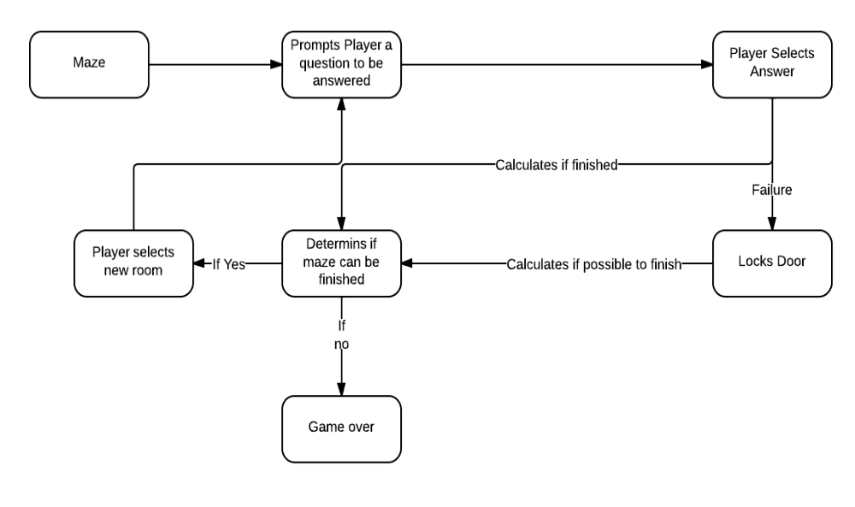
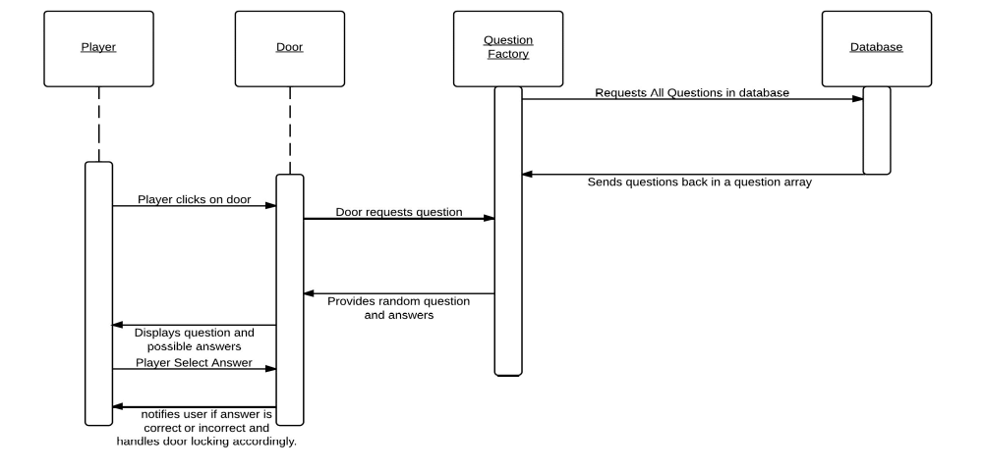
Sequence:

